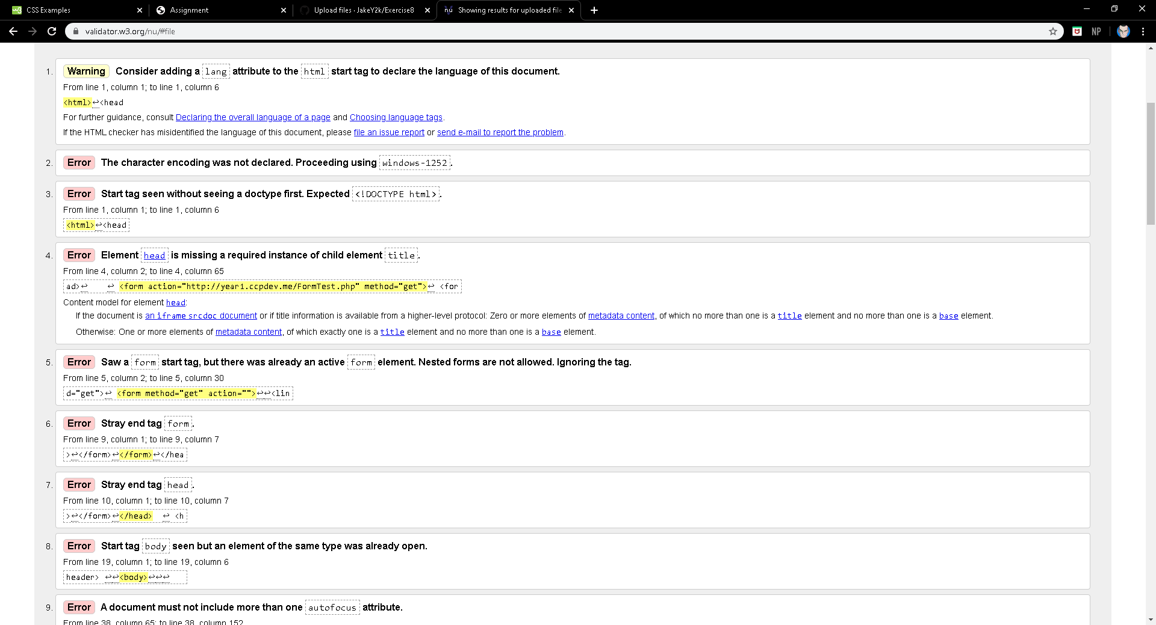GitHub URL: <https://jakey2k.github.io/Exercise8/>